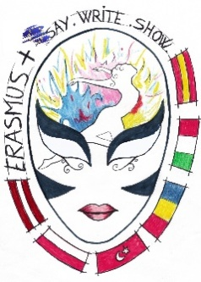

SAY.WRITE.SHOW – DEVELOPING STUDENTS’ AND TEACHERS’ COMMUNICATION SKILLS

Minutes of the working session:
Gavorrano, 31 May – 1 June 2018

- The official welcoming.
- Monitoring the project activities
- Discussion agenda presented

A 33 – TEACHERS’ RESOURCE BOOK

The Italian and the Polish partners presented the book.

Conclusions:

- after coming back from Italy, there will be a week for the partners for corrections, suggestions and opinions on the Resource Book;
- the Word version of the RB will be sent to everybody;
- after a week, taking any suggestions into consideration, the file will be converted into a PDF file and sent to Spain to upload at the project site;

- a good suggestion for each partner – prepare a booklet of the RB activities in the English-national language version and print it for the school use.

A 27 – EUROPEAN PLAY

The partners shared their impression of the activity, discussed the dissemination of the activity in their school.
Conclusions:
- the Spanish partner need to upload the video on the project site;
- the film should be also uploaded onto the Facebook site of the project and Twinspace.

A 19 – ONE PAINTING - MANY STORIES

- discussion about A 27 and A 19 – partners’ impressions

Conclusions:

- the booklet and the recordings have already been uploaded onto the project sites.

A 4 – PROJECT WEBSITE

Conclusions:

- all the partners should check the project website and send the Spanish partner the missing materials, as this very site should reflect project’s implemenation;
- the deadline for sending the missing materials is the end of June.

A 29 – DISSEMINATING MOBILITY IN LATVIA C3, C4

Conclusions:

- the vlogs from the blended mobilities should also be sent to the Spanish partner to upload onto the site – it is important for the dissemination as it reflects the participants’ opinions.

A31, A32 – END-OF-THE-PROJECT QUESTIONNAIRES FOR PUPILS AND TEACHERS

Conclusions:

- partners and the participating students and teachers should do it until the beginning of August, then it will be converted into a PDF file and sent to the Spanish partner to upload onto the project site.

- REPORTING PROJECT ACTIVITIES

Each partner reported on the project activities (A19, A27, A23)

Conclusions:

- remember to send to Claudia, the main coordinator,:
- reports from the activities A19, A27, A23 (the format for activities reporting);
- the dissemination report (the table sent for reporting at the end of the first year of the project).

- MOBILITY TOOL

Conclusions:

1. The Romanian coordinator presented suggestions by the Romanian NA:
- when writing the final report, keep the codes of the activities as they have been used in the project application, regardless the actual changes in the schedule:

C1, C2 – Spain
C3, C4 – Latvia
C5, C6 – Bucharest

When you report them in the Mobility Tool , give the real dates.

2. If you have taken extra students to the blended mobility meetings ( Romania, Spain, Latvia), don’t provide that information in the Mobility Tool, but write about it in the management implementation section of the final report.

There should be only the initially planned number of students in the mobility reports.

3. There will be further guidelines for the final report by Claudia after she has had the meeting with her NA.

- DISCUSSION ON THE FINAL IMPLEMENTATION OF
THE PROJECT BY EACH PARTNER

- MEETING EVALUATION

- GETTING PARTICIPATION CERTIFICATES

THE PHOTOS OF THE MOBILITY IN ITALY

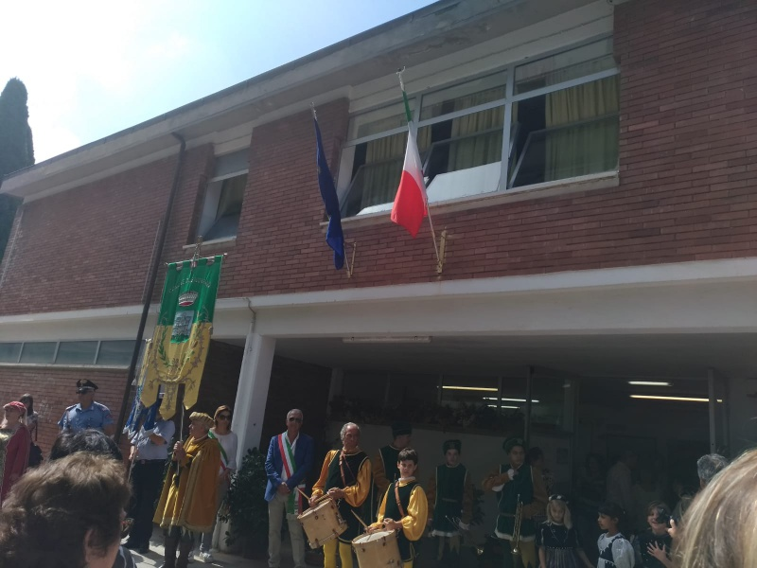
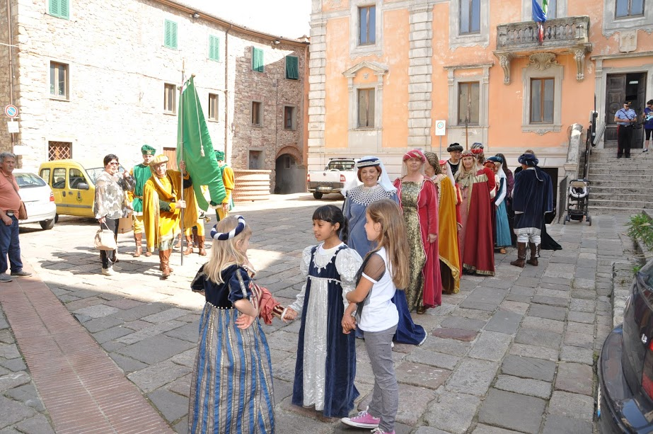

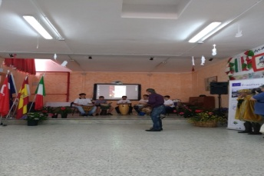
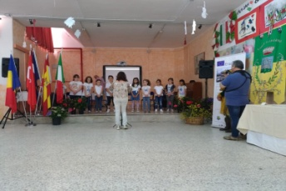
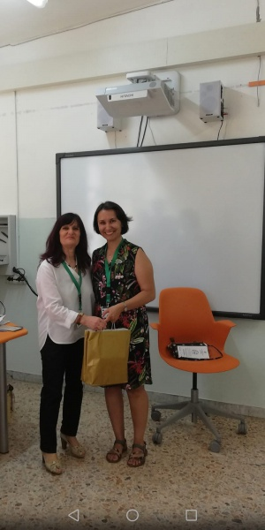
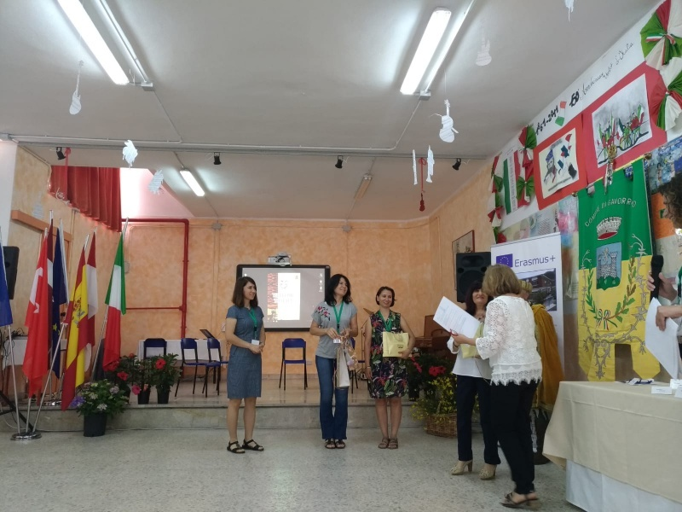
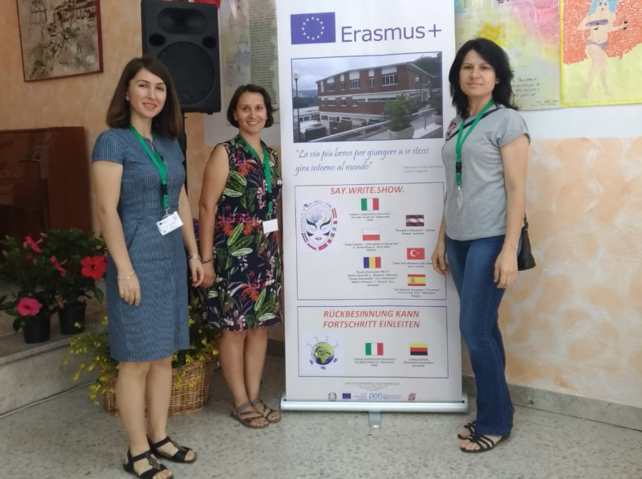
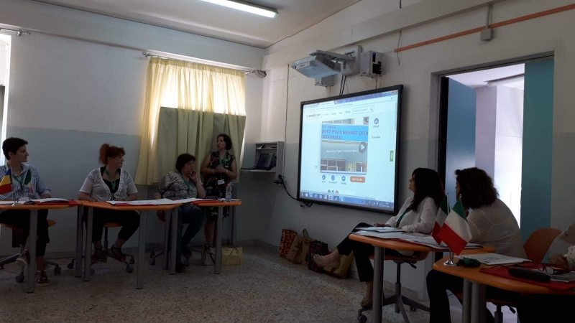
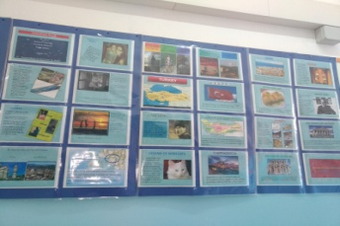
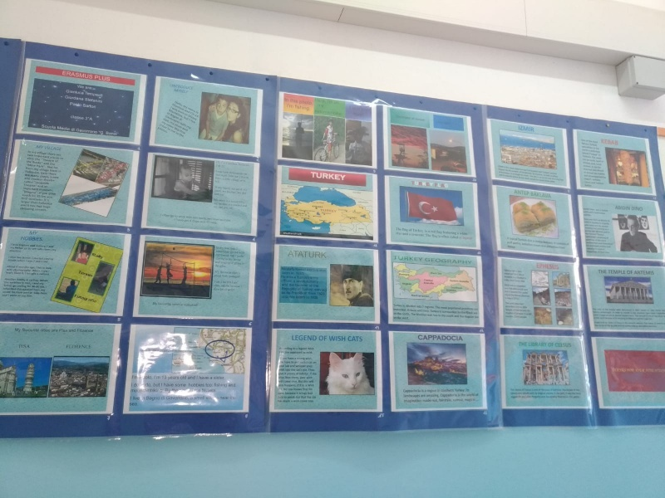
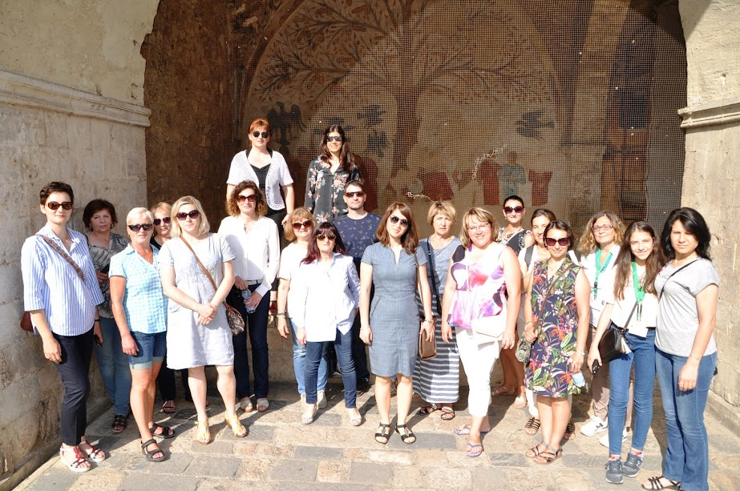
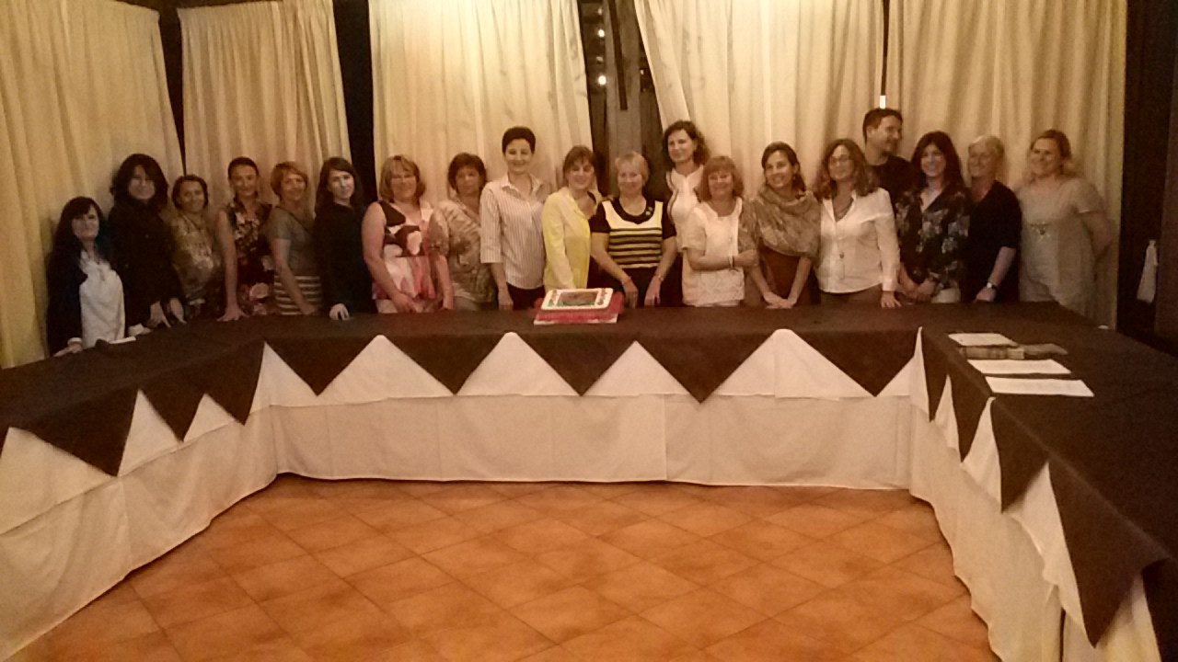
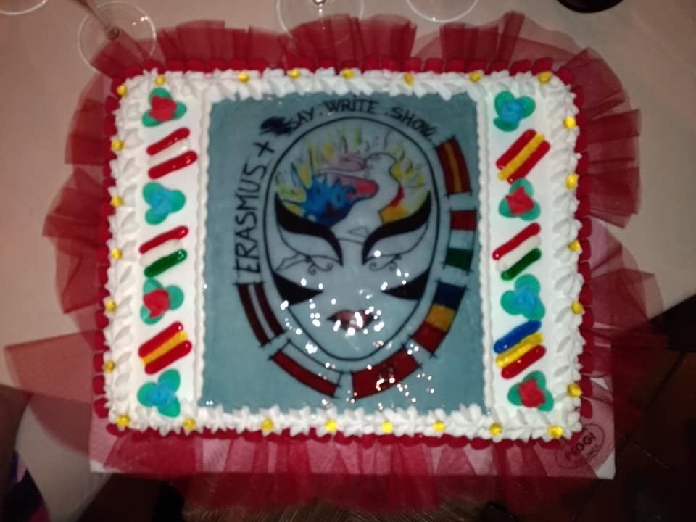

In the mobility, we distrubuted our project sweets and fans to the participants.
We presented the presentation of the second period for our school from story jumper. https://www.storyjumper.com/book/index/56388965/5b0ba108d0e2c

